The Codename One plugin is the tool that enables us to apps with NetBeans. You have installed the plugin, but the creators of the plugin continue to make it evolve, adding new functionalities to it.

Level of difficulty:   
Estimated time: 5 mn + download time

[**www.codapps.io**](http://www.codapps.io)by Clement Levallois **@codapps_io** [**www.coursera.org/learn/codapps**](http://www.coursera.org/learn/codapps)



**Module 1: Installation of useful tools for the course**

*How to check for updates for the Codename One plugin*

It is important to have the latest version of the plugin installed. When you open NetBeans, it actually checks for you if there is any update available:

* If an update is available, you will get this little speech bubble at the bottom right corner:

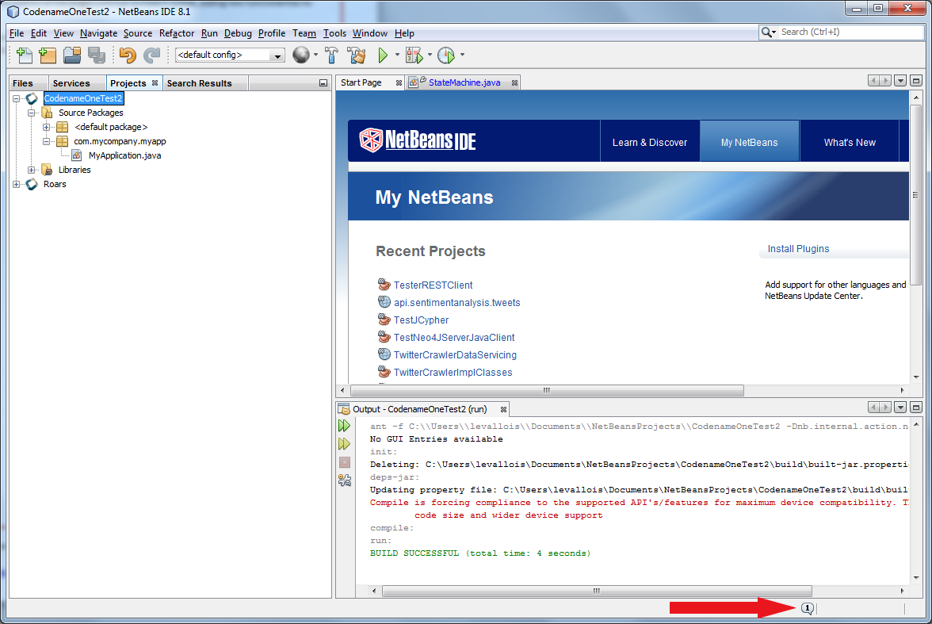

f there is no bubble, you’re good! Go to the next page of this tutorial.

If there is a bubble, it means updates are available. Click on the bubble and follow the instructions to download and install the updates. You can have updates for the Codename One plugin, but also for other components of NetBeans you are not familiar with. I advise you to install all the updates available.

**Now, what if you had already created an app in NetBeans? It will not automatically benefit from the updated plugin. If you have already created an app, follow these steps:**

Level of difficulty:   
Estimated time: 5 mn + download time

1. Right click on the project’s name, select properties

[**www.codapps.io**](http://www.codapps.io)by Clement Levallois **@codapps_io** [**www.coursera.org/learn/codapps**](http://www.coursera.org/learn/codapps)



**Module 1: Installation of useful tools for the course**

*How to check for updates for the Codename One plugin*

1. In the window that opens, click on “Update project libs”
2. Right click on the project’s name, click on “Clean and Build”. You should be good to go!

LAST STEP: it sometimes happens that the address that NetBeans checks for updates is incorrect. In this case, NetBeans will never find updates and you’ll be stuck with an old version of the plugin!

Here is how to make sure you have everything correctly setup (see picture below)

In the NetBeans menu, click on Tools -> Plugin

In the window that opens, click on tab “Settings” (last tab on the right)

* 1. Select the line “CodenameOnePlugin Update Center”, it should be highlighted
  2. Verify that the url (web address) on the right is:

<https://www.codenameone.com/files/netbeans/updates.xml>

* 1. If it’s not, then click on “edit” and put this address above instead.
  2. By default, updates are checked every week. Change this for “every startup”.

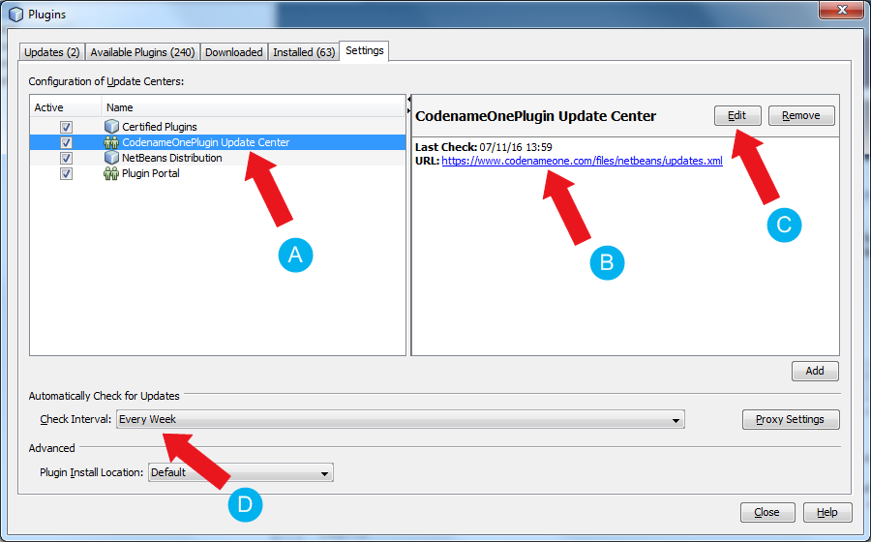That’s it! You had to do it just once, next time just check if there is a bubble at the bottom right corner when you open NetBeans!